My trip experience of London

Dear Reader,

I am Nick Tailor. I am sharing my 15 days' experience of visiting the capital city of England “London” from India. I am an ordinary software guy who is working with one of the topmost reputed company based in the UK. It was the month of January 2020 and was traveling with my 3 other office colloquies. We have been assigned cabs from Pune to Mumbai to catch our flight from Mumbai. So that was connecting journey. Mumbai to Abu Dhabi and then Abu Dhabi to London. The airline was Etihad. That was the first time when I was traveling with one of the best and largest passenger aircraft Airbus A380.

We reached London in the afternoon and hired a cab to the hotel. We were charged twice the regular amount because that was our first time and we were pretty exhausted from a long journey and time zone difference so we paid 120 pounds from Heathrow to Hotel for 18 miles. Normal charges would be between 50 to 60 pounds.

My first feelings about London was Clean Roads, European Architecture buildings, Lane system for a vehicle, Traffic in central London, Cold monsoon, and White People. I have seen a good amount of white people only in my childhood in India when they use to visit rural India for tourism. It was like a dream come true for me to experience all these in the first place.

We checked into the hotel “Thistle Bloomsbury” and went straight into our rooms. The rooms were pretty nice.

The bathroom was a little small for me because of my 5’11 height. Tap water was drinkable with good taste. My room included breakfast and dinner as well because all charges were already paid by the company.

So overall it very nice starts of my exciting journey and I will share all my experience with you here.

Hotel Thistle Bloomsbury <https://www.thistle.com/en/hotels/london/bloomsbury-park.html>

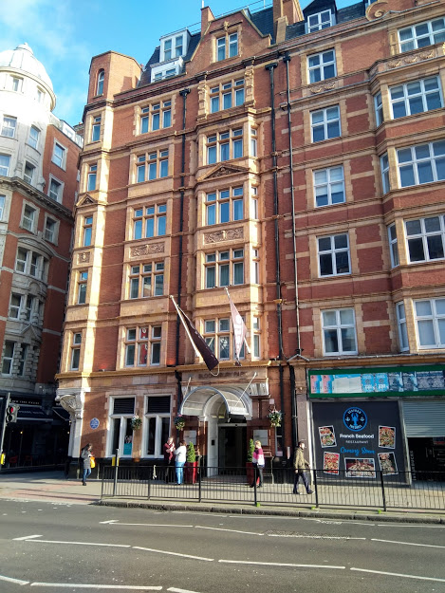

As you know our primary purpose was official work so next day we dressed well (Only formals were allowed) and then headed for office on Berners Street. This was an only 15-minute walk to the office.

Started office as usual. I got to meet all teammates from all different countries, said hello. Checked cafeteria, floor plans, and working people.

My first-day experience in the office was

1. Diversity of People: I was just roaming on the floor in break time and come across many people who belonged to many different countries, ethnicity and all was going smooth.
2. British people flush toilet papers.
3. They talk a lot and talk with all happiness and sense.
4. Eat on the table if you want and can mind your own business.
5. Respect is there for all kinds of people and you can sit next to a senior project manager as well.
6. Women get respected in every manner.
7. Politeness and a sense of humor are great as it should be.

So, all get set and we started working. Everything was going very very fine.

And here comes the list of places which I visited on weekends and after office hours.

1. Windsor Castle
2. Big Ben
3. London Eye
4. London Bridge
5. British Museum
6. Primark
7. Covent Garden

I will share my experience of each place journey and will provide you some hints on how places feel like

**Windsor Castle**

Windsor Castle is one of the official residences of England’s queen her majesty Elizabeth second. This is the place where Prince Harry and Meghan Markle got married and former king of the united kingdom George VI is buried.

On Friday night we decided to visit the castle while having dinner at the hotel. We all agreed after checking monsoon. No rain. The next morning we started our journey. First, we took an oyster card to use tube railways to reach a place where we can take a bus to the castle. London to Windsor castle journey is of 1hour and 20 minutes on a bus. Unfortunately, buses to the castle do not accept oyster card so we paid in cash and got our seats. I was seating at the upper deck first-row corner seat.

The journey begins and I started observing all things on roads. Houses planning, Roads, Different types of vehicles, people in buses, and whatnot. You know what was the most satisfying moment of the journey that there is no honking on roads. Just peace, roads, and me. I enjoyed the bus journey.

We reached on time and started our walk towards the castle. I saw different kinds of shops, musicians on street, unique things, Hats selling shops and free people. All were British kind of. And cold which I like the most.

we got our tickets from the queue and entered the castle. The audio guide was there and I took it but I am the kind of person who just wanted to feel this moment so I did not listen to any of it.

Clicked pictures of some couples from their DSLR and feels good about it.

Clicked many pictures on the castle. Inside castle photography was not allowed. But the interior is all about British history, Arts, culture, paintings, kings, and Queens. Spent some time in George’s chapel and prayed to Jesus. Got some inner peace.

Felt damn, the queen has such a cool life.

End of the day. Got our bus back, catch some tube trains and its Hotel Room. Feeling awesome, historical, and overall this was worth to visit for me.

Here is some glimpse from Castle

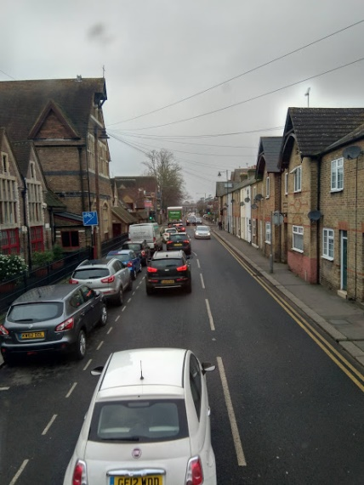 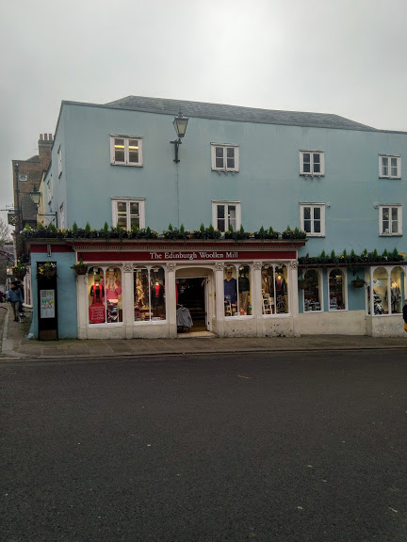 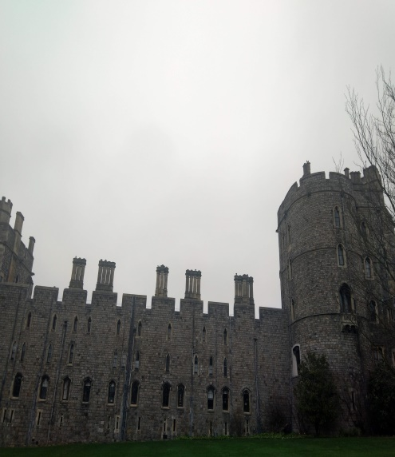

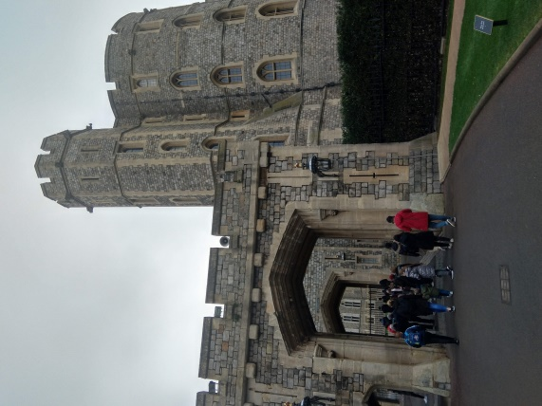 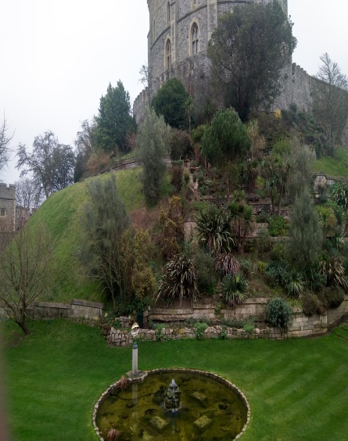

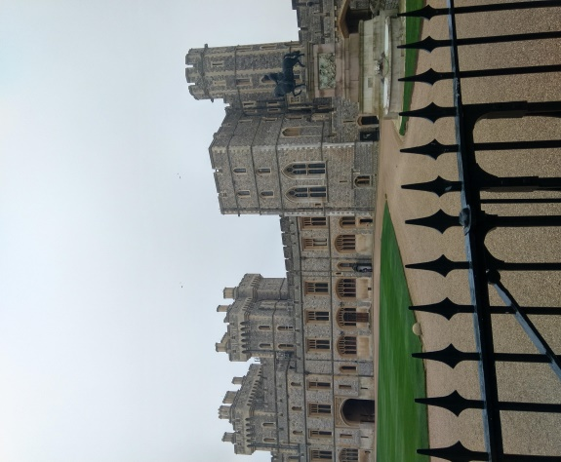

**Big Ben, London Eye & Palace of Westminister**

I must say the heart of London lies here. Westminster palace (Parliament of London) is an old and very significant building in central London. If you stand on Westminister Bridge and look around you will see amazingly built Westminster palace, big ban, and London eye.

To visit the London eye you need to walk down from the bridge along with Thames River. Many shops are there and some playful events always use to happen there. I bought some keychain which shows of London.

Unfortunately on the day of my visit big ben and the London eye both were under maintenance and was closed. So that was some dishearting. However, we spent 2 hours on the Thames river and felt the culture and watched boats, Clicked many pictures and I most importantly I was enjoying a very cold temperature. May be temperature was around 6 or 7-degree Celsius.

We spent half a day there and started our journey towards the London Bridge which is about an 11-minute journey from Westminster Bridge.

Here are some glimpse of Westminister palace, big ben and London eye

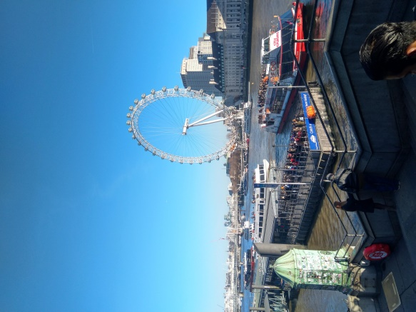 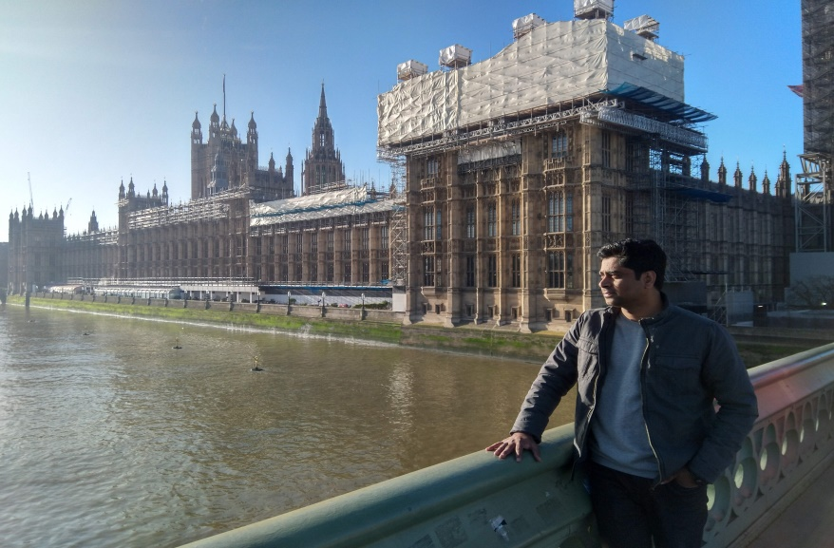

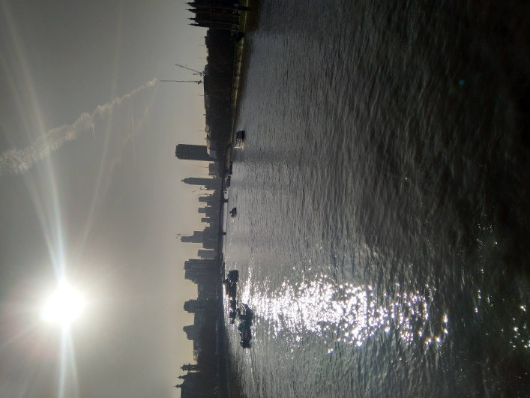 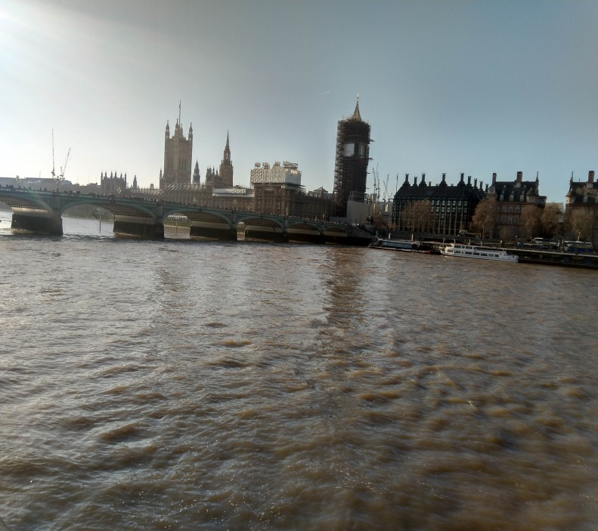

**London Bridge**

I must say the views for the London bridge are mesmerizing in all ways. There is a big royal palace near the London bridge ( Same as a fort ) which was paid to visit and a bit expensive so we decided not to visit. Rather we took a long walk near the bridge to explore details of the bridge.

As boats passing by and sitting on a bench alongside Thames river I could not hold my excitement.

London Bridge is also a popular tourist destination so you will see a lot of people with diversity and race. Walk above the bridge and just feel how beautiful London is.

Picturs From London Bridge

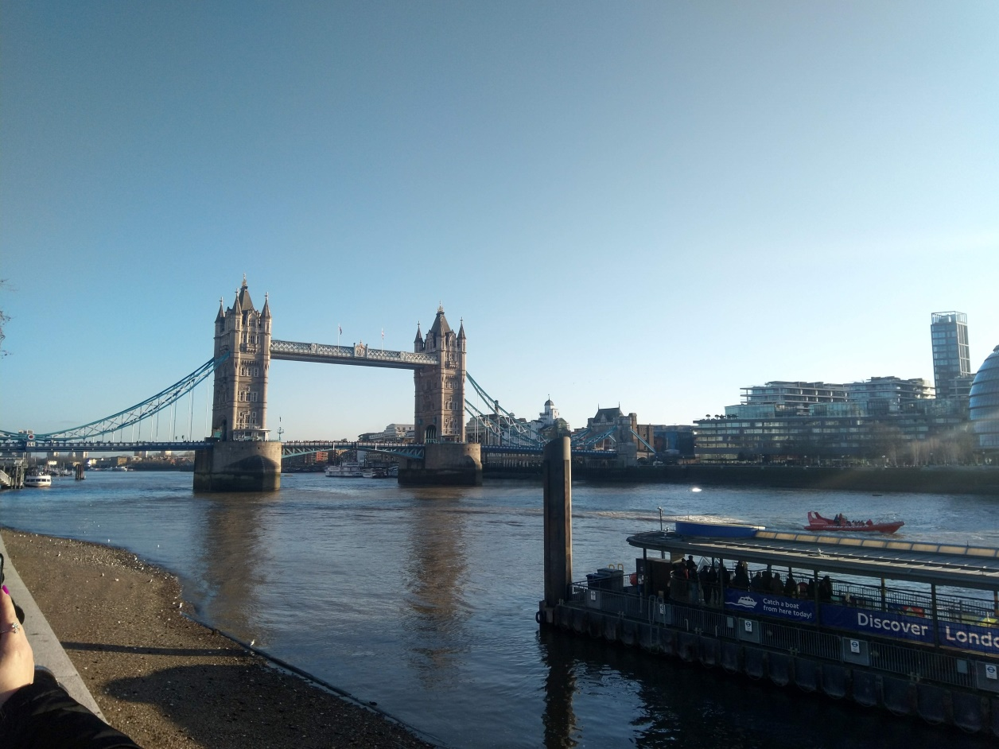

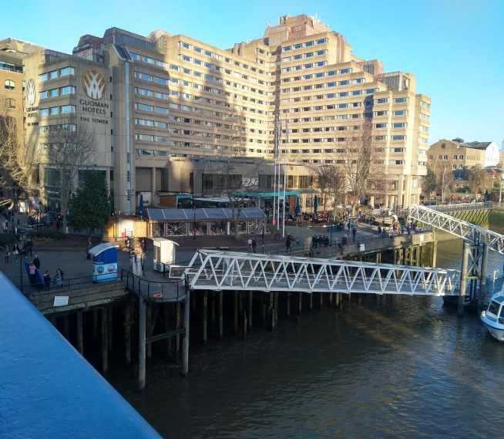 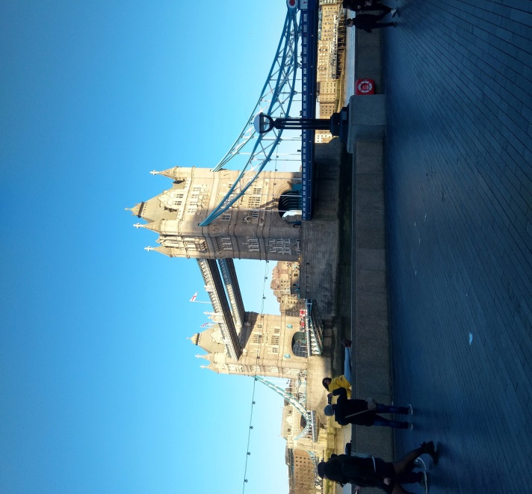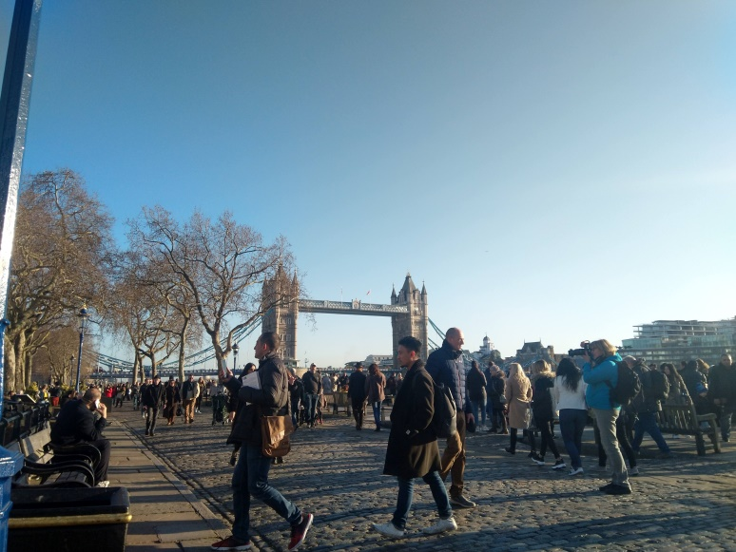

**British Museum**

The best part of my residing hotel was that all major tourist destination was near to me. British museum was about 10 minutes walk only. and I just liked the way people cross the road with all sense and you have proper signal and no one honks.

It was a fine weekend day.

But unfortunately, I caught a fever and was not feeling good to visit any places. However, my colleagues left in the morning to visit more of London and for some shopping but I slept till afternoon.

As I woke up I finally got the courage and decided to visit the museum on my own.

I reached the museum and took my place in a long queue for entering. Entry is free at the museum. However, you need to pass through security checks. Most of the people were Chinese and Japanese. I saw only a few British white people in the queue.

So I got my entry and started exploring Asian history first. I was very excited to see all the old monuments, rocks, paintings of India.

I have visited many different sections like Egypt, Japanese, Chinese, Roman history but I was having a fever so I was not feeling comfortable visiting and explore every aspect of the museum. So left in 2 hours.

Overall it gives you the vibe of an old and ancient civilization of many continents. British people ruled a long land so the museum has a very fine collection of antiques. All clean, audio guides, good people around you, and a great food mall inside will give you the most of your trip.

I just took french fries outside the main gate with tomato catchup and left the museum to reach my Hotel.

Picture of my visit.

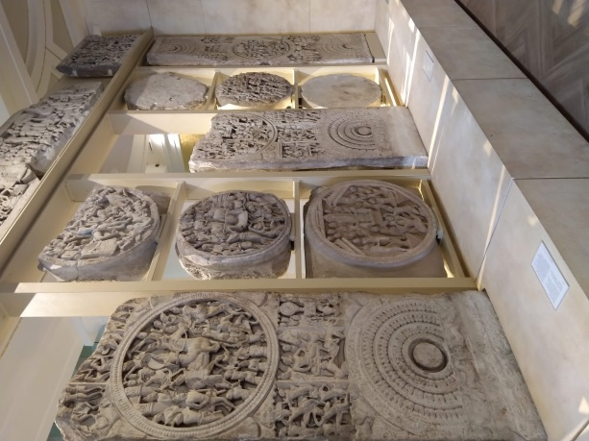 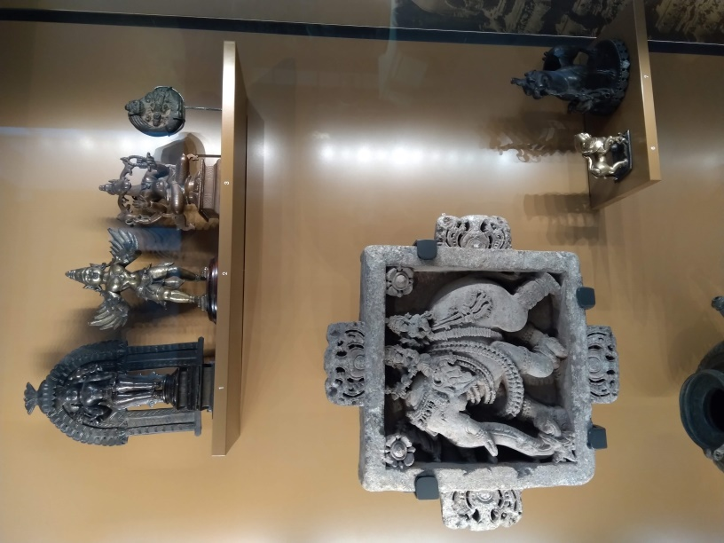

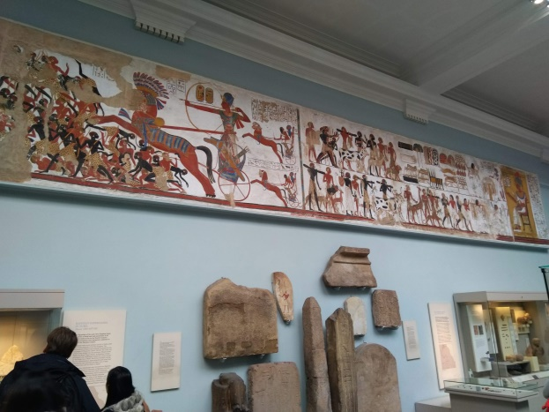 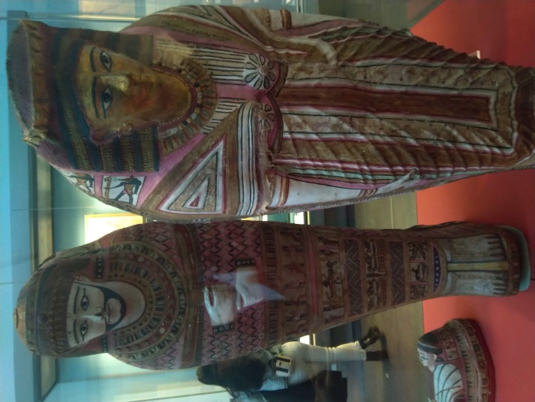

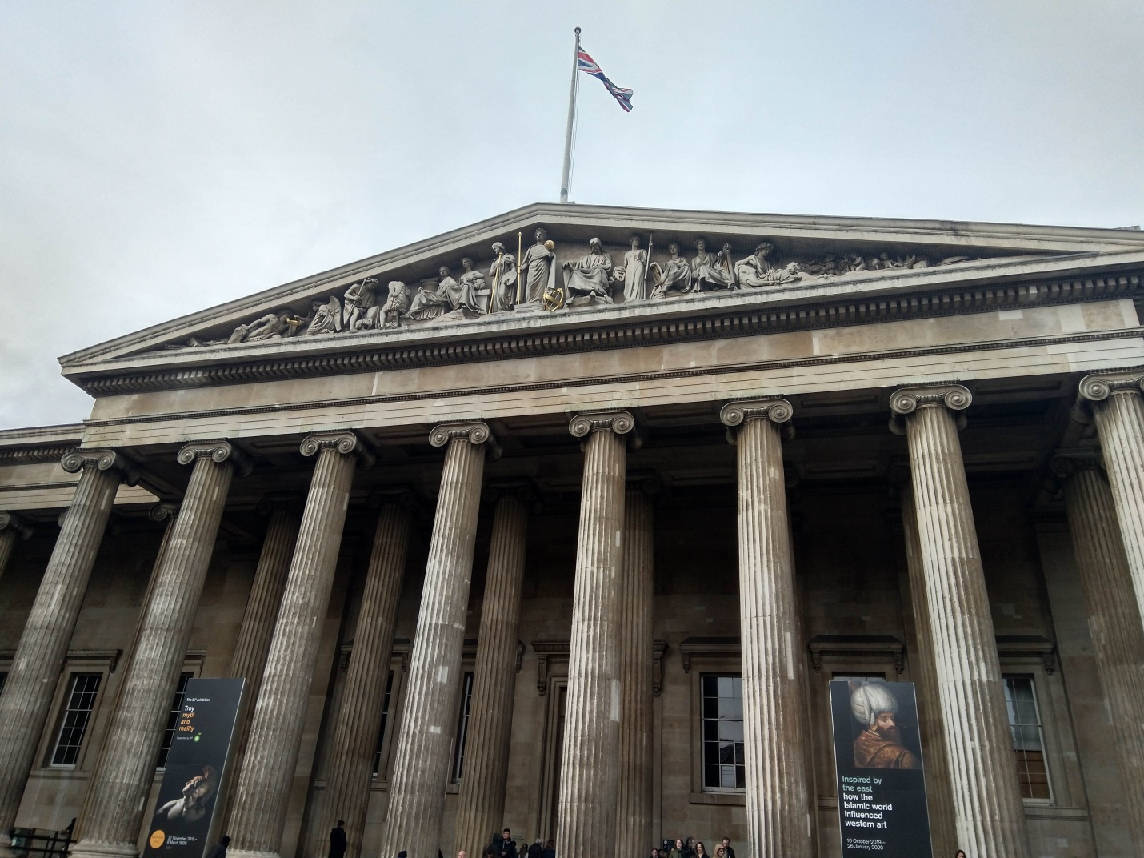

**Covent Garden**

We visited the convent garden after office hours in the evening time. Maybe at 7 PM.

Convent garden is beautifully built street architecture, lots of shops, entertainment destinations with the most beautiful walkway.

And in the evening time, street light gives extra awesomeness to these views.

I think this place was like harry potter set or the walkway which Katrina Kaif and Hritik Roshan used in the movie Zindagi Na Milegi Dobara.

We spent about 2 hours here.

We were thinking to have dinner at a convent garden but you know our hotel has already a dinner facility so why put some expensive Euros for food. So we left.

Picture of my visit

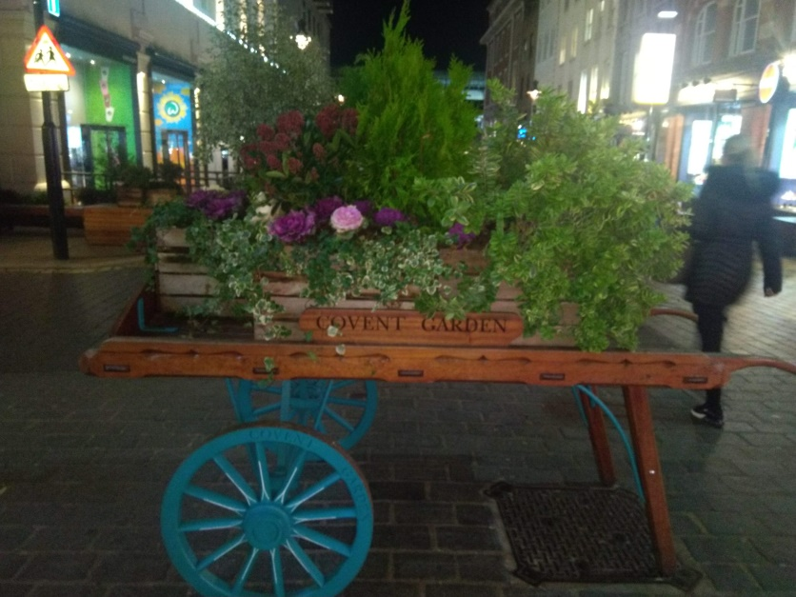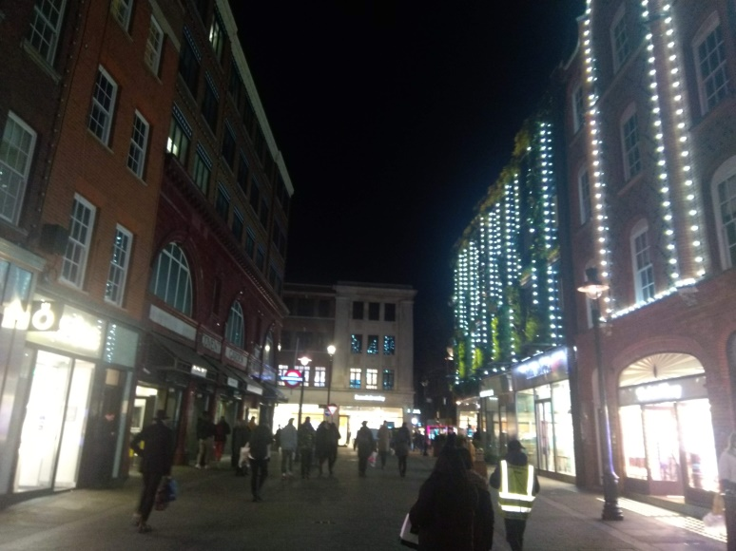

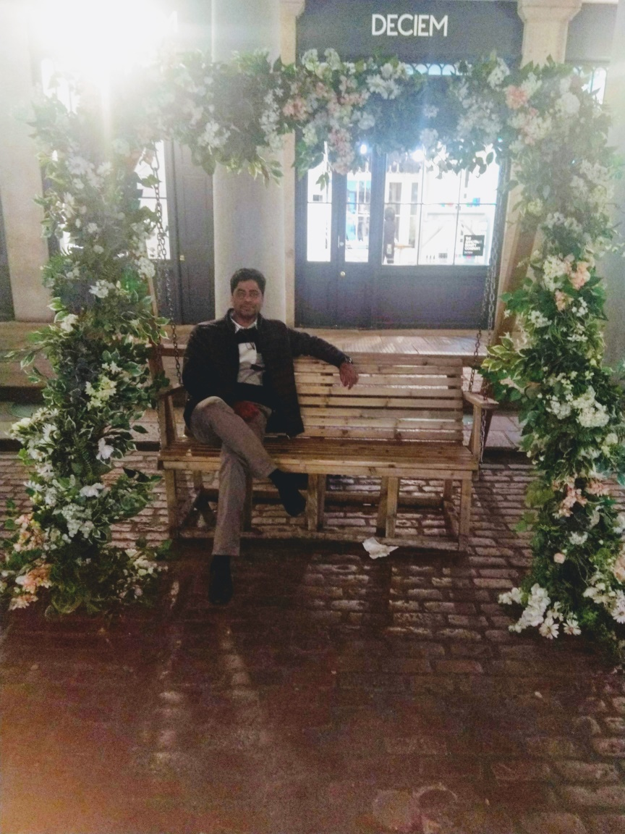 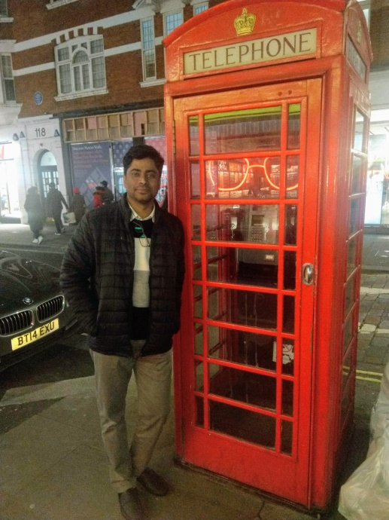

**My Primark Shopping Experience**

Even before my journey started in India I heard from many of the office friends that if you are visiting London then you must visit the Primak shop for shopping. After lots of suggestions, I carried extra cash of 100 Euros just for shopping.

I was excited to buy all the branded clothes at affordable or cheap prices from London Primark.

We visited Primark after office hours. The shop was near so using the walkway we reached there.

I was only interested in clothes shopping so straight forward I went to the men’s clothing section and my first impression was “What the hell”.

Many cloth brands were made in Bangladesh, Pakistan brands. I did not see any expensive UK brands like Burberry, Stella McCartney, or Paul Smith clothes at an affordable price. 1 Jeans was about 10 Euro having average quality.

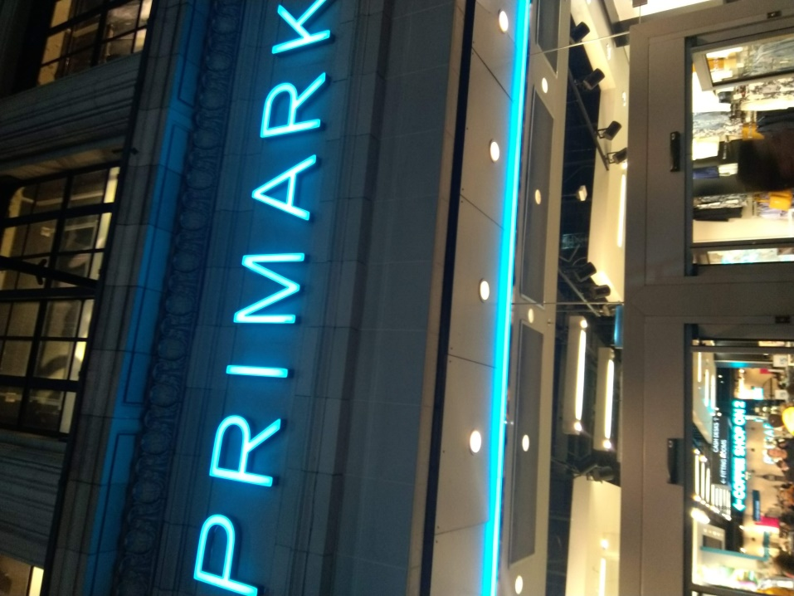

I got disappointed that I could not buy any of it.

So I checked many different sections just to find something useful but I observed that the same price item is easily available in India at the same price so why bother. ( By the way, India is a developing country so prices are not skyrockets for now )

I think Primark is about daily household items, Regular Cloths, and cheap imported items that you can purchase and use at home.

And just to clarify I am not judging that Primark does not keep any big brand items. The point is that I was having different expectations at that time.

My friends purchased some items. After 3 hours of tiredness, we reached a hotel. Took our regular Pizza food with red wine and gone for asleep.

**Any Scary Moment?**

**No.**

London is a very safe and beautiful city. Traffic system, Lane Ways, public transport are very sorted and works very smoothly.

No one tries to break rules at any place and at the same time you have your freedom for your activities.

British people have a very good sense of humor and they will help you without your origin, color, or ethnicity.

Just 1 Scary moment which I faced was that I was walking towards a hotel at night time. I think I was out for coffee that evening.As I was walking and passing 1 bus stop I saw a couple who were kissing and saw them in dark light at sudden so I got scared.

Haha.

Don’t laugh. This is not very normal here in India. As soon I saw them I tried to escape the walkway and tried to jump on the road. But somehow I managed.

I felt dam fool for this.

But I think it was not about seeing a couple kissing but it was more about watching them in dark light at the sudden moment and I was indifferent thinking so that might be the reason for this as well.

I passed the bus stop and started walking on a more light shade to avoid more surprises.

Overall I find London is very safe. At some selective place, you might be cautious about pickpocketing.

**Journey to the Home**

We came to the end of an awesome journey. After 15 days we were flying back to Mumbai via Abu Dhabi.

I packed all my stuff. checked out of the hotel and reached Heathrow Airport.

So after 10 hours of travel, we reached Mumbai and then our cabs dropped us at hour homes in India.

I think I am much missing this journey. Hope to see more of England soon.